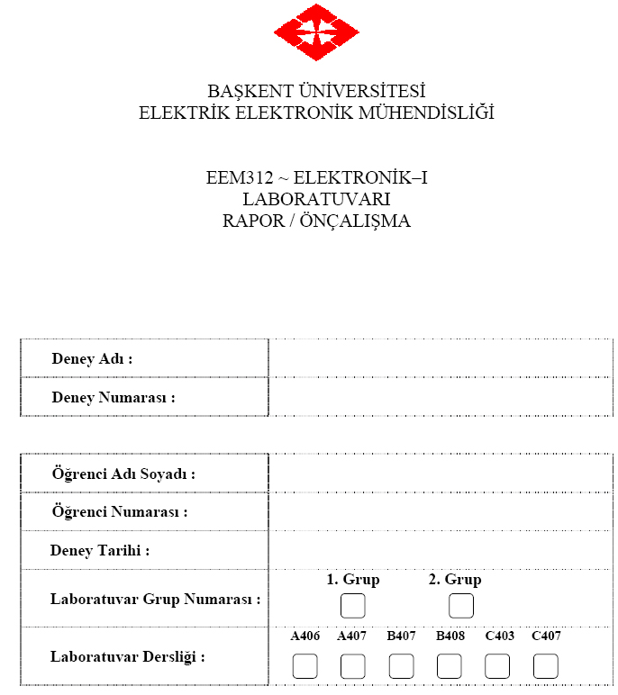

1)
a)
C_{int}=1pF için;
*Gökhan AVDAN 20493204

VIN 1 0 pulse (0 3.1 0 1n 1n 5n 10n)
CL 2 0 6.9f
M2 2 1 0 0 MOSN W=2u L=1u NRS=0.333 NRD=0.333
+ AD=6.5p PD=9.0u AS=6.5p PS=9.0u
M1 2 1 3 3 MOSP W=5.92u L=1u NRS=0.111 NRD=0.111
+ AD=16.2p PD=11.4u AS=16.2p PS=11.4u
VDD 3 0 DC 3.2

.CONTROL
TRAN 1p 20ns
PLOT V(2) V(1)
.ENDC
.END

.MODEL MOSN NMOS LEVEL=2 LD=0.15U TOX=200.0E-10
+ NSUB=5.36726E+15 VTO=0.743469 KP=8.00059E-05 GAMMA=0.543
+ PHI=0.6 U0=655.881 UEXP=0.157282 UCRIT=31443.8
+ DELTA=2.39824 VMAX=55260.9 XJ=0.25U LAMBDA=0.0367072
+ NFS=1E+12 NEFF=1.001 NSS=1E+11 TPG=1.0 RSH=70.00
+ CGDO=4.3E-10 CGSO=4.3E-10 CJ=0.0003 MJ=0.6585
+ CJSW=8.0E-10 MJSW=0.2402 PB=0.58

.MODEL MOSP PMOS LEVEL=2 LD=0.15U TOX=200.0E-10
+ NSUB=4.3318E+15 VTO=-0.738861 KP=2.70E-05 GAMMA=0.58
+ PHI=0.6 U0=261.977 UEXP=0.323932 UCRIT=65719.8
+ DELTA=1.79192 VMAX=25694 XJ=0.25U LAMBDA=0.0612279
+ NFS=1E+12 NEFF=1.001 NSS=1E+11 TPG=-1.0 RSH=120.6
+ CGDO=4.3E-10 CGSO=4.3E-10 CJ=0.0005 MJ=0.5052
+ CJSW=1.349E-10 MJSW=0.2417 PB=0.64
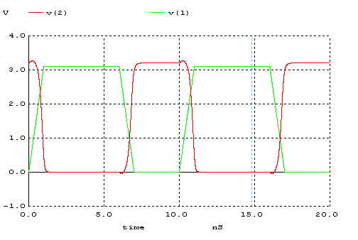
t_{r} | t_{f} | t_{PLH} | t_{PHL} | 2.5V’dan 0.7’a  Geçiş Süresi
1,35 ns | 1,25 ns | 0,89 ns | 0,875ns | 0,625 ns

*Gökhan AVDAN 20493204

VIN 1 0 pulse (0 3.1 0 1n 1n 5n 10n)
CL 2 0 6.9f
M2 2 1 0 0 MOSN W=2u L=1u NRS=0.333 NRD=0.333
+ AD=6.5p PD=9.0u AS=6.5p PS=9.0u
M1 2 1 3 3 MOSP W=5.92u L=1u NRS=0.111 NRD=0.111
+ AD=16.2p PD=11.4u AS=16.2p PS=11.4u
VDD 3 0 DC 3.2

.CONTROL
DC VIN 0 3.2 0.001
PLOT V(2) vs V(1)
.ENDC

.MODEL MOSN NMOS LEVEL=2 LD=0.15U TOX=200.0E-10
+ NSUB=5.36726E+15 VTO=0.743469 KP=8.00059E-05 GAMMA=0.543
+ PHI=0.6 U0=655.881 UEXP=0.157282 UCRIT=31443.8
+ DELTA=2.39824 VMAX=55260.9 XJ=0.25U LAMBDA=0.0367072
+ NFS=1E+12 NEFF=1.001 NSS=1E+11 TPG=1.0 RSH=70.00
+ CGDO=4.3E-10 CGSO=4.3E-10 CJ=0.0003 MJ=0.6585
+ CJSW=8.0E-10 MJSW=0.2402 PB=0.58

.MODEL MOSP PMOS LEVEL=2 LD=0.15U TOX=200.0E-10
+ NSUB=4.3318E+15 VTO=-0.738861 KP=2.70E-05 GAMMA=0.58
+ PHI=0.6 U0=261.977 UEXP=0.323932 UCRIT=65719.8
+ DELTA=1.79192 VMAX=25694 XJ=0.25U LAMBDA=0.0612279
+ NFS=1E+12 NEFF=1.001 NSS=1E+11 TPG=-1.0 RSH=120.6
+ CGDO=4.3E-10 CGSO=4.3E-10 CJ=0.0005 MJ=0.5052
+ CJSW=1.349E-10 MJSW=0.2417 PB=0.64
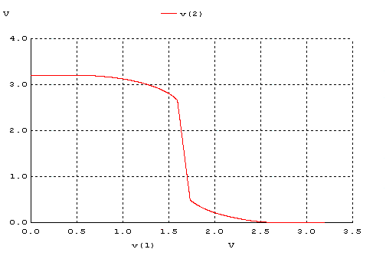

b)C_{int}=10C_{g}
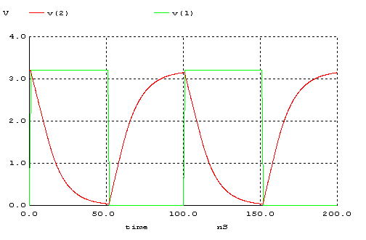

t_{r} | t_{f} | t_{PLH} | t_{PHL}
37,45 ns | 36,75 ns | 18 ns | 21 ns

